- Up to now, we saw two important things User Detail Service and Password Encoder.
- Let’s explore more on them along with how to create multiple users for our app.
- 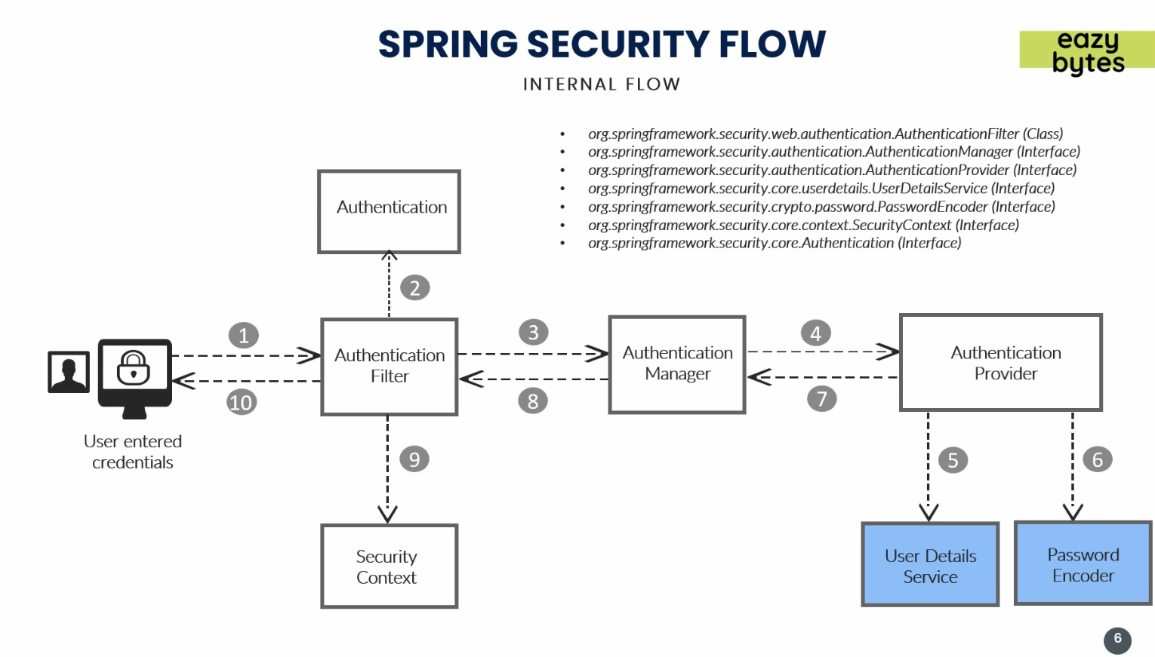
- Till now, we had only single user configured in application.properties file.
- 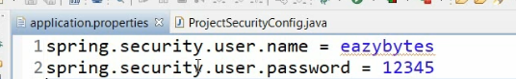
- But our app must support as many users as we want along with their roles and authorities.
- Let’s configure the followings:
  - Users.
  - User Details Service.
  - Password Encoder.
  - Authentication Provider
- 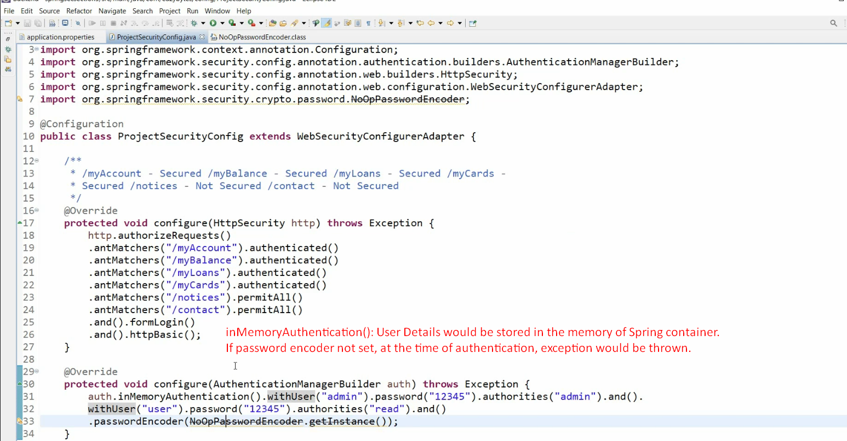
  - auth.inMemoryAuthentication():
    - This means that all the users would be stored inside the memory of spring container which will be leveraged by spring security while performing authentication and authorization details.
  - Password Encoder:
    - If not passed, at the time of authentication, spring security would throw an exception saying I don’t know how to validate your password as maybe your password is stored as a normal text, or encoded or encrypted inside the memory of spring container.
So, always pass password encoder.
- 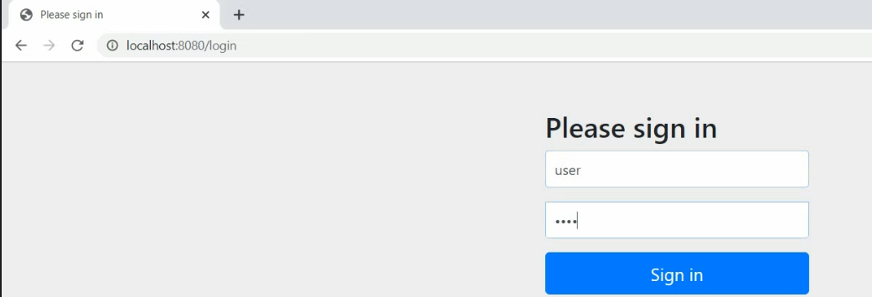
- See, we are able to maintain a number of user details in spring security configuration.
- This is not Production-Ready-App.

